Master Thesis

***A low Iq, high efficiency DC/DC converter with maximum power point tracking for piezoelectric generators***

**1 Introduction and Motivation**

A piezo electric generator produces electricity upon application of mechanical stress. The output voltage is an alternating waveform. This is then rectified through a bridge rectifier and a large input capacitor.

This voltage is unregulated and the unregulated DC voltage so obtained from the sample piezo considered for this thesis varies from a value of 10 up to 70 Volts. This voltage has to be regulated in order to obtain a constant output of 3.3V. This is achieved through the implementation of a DC-DC converter.

Though the voltages are of a respectable level, the currents obtained are in the order of a few microamperes. This poses a problem as the output of the piezo and hence the input of the DC-DC converter is in the range of microwatts. A typical operating point considered for this converter is 400uW @ 25V. Also the operating range for power is considered typically between 100uW and 5mW.

Thus the need for an ultra-low power, high efficiency converter arises whose operating range is in microwatts (whose own power requirements is very low - ideally a few microwatts).

The equations for the signals in this converter are to be simulated in order to obtain the efficiency curves with respect to variable parameters such as switching frequency, duty cycle, values of inductances, capacitances, resistances etc. From these efficiency curves, the circuit components and controllable parameters are so chosen as to obtain maximum possible efficiency.

Efficiency is also increased through the use of Maximum Power Point Tracking implemented through an ultra-low power mixed signal matrix from Silego Technologies. These ICs have a quiescent current in the range of microamperes and that helps in reducing the power consumption compared to microcontrollers which require a few hundred microamperes even in the ultra-low power modes.

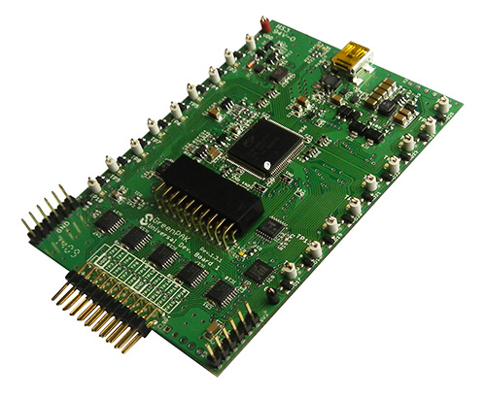

Figure 1: Silego Development Board [1]

**2 DC-DC Converter Design**

**2.1 Choice of Converter Topology**

The initial study involved an understanding into the working of different topologies of DC-DC converters to reason out choice of the flyback topology. The different topologies involved were as follows:

Buck: This topology is not suited for applications where isolation is required.

Boost: Also non-isolated, the boost steps up the voltage rather than stepping it down, which is not suitable for the current application.

Buck-boost: Has the disadvantage of inverting the output voltage. Another disadvantage to the buck-boost topology is that the switch does not have a ground, which complicates the drive circuit.

Flyback: One advantage of the flyback topology over the other isolated topologies is that many of them require a separate storage inductor. Since the flyback transformer is in reality the storage inductor, no separate inductor is needed. This, coupled with the fact that the rest of the circuitry is simple, makes the flyback topology a cost effective and popular topology.

Forward: While efficiency is comparable to the flyback, it does have the disadvantage of having an extra inductor on the output. Suitable for higher output currents.

Push-Pull: Switching control can be difficult with push-pull converters, because care has to be taken not to turn on both switches at the same time. The other disadvantage to the push-pull topology is that the switch stresses are very high. [2]

Thus, through the above comparison of different topologies, the flyback seems the most apt for this ultra-low power converter and its working and design process is pursued and discussed in the following sections.

**2.2 Flyback Converter and Modes of Operation**

The flyback converter is the most commonly used SMPS circuit for low power applications. It is evolved from a buck-boost converter. The inductor in a buck-boost converter is replaced with a coupled inductor. This provides 2 main advantages, namely, non-inverted output with respect to the input and isolation between input and load.



Figure 2 Flyback Transformer

A diagram of an ideal flyback converter circuit is shown above. The major parts of a flyback converter include a flyback transformer (coupled inductor), a switch and a diode (for rectification). Note that the flyback transformer is connected such that the two windings have an opposite polarity. This ensures that the polarity of the output voltage is the same as the input voltage. A regular flyback converter would have a resistive load along with a capacitor in parallel as shown in Figure 2. But in this thesis we charge a battery. The switch is continuously toggled in order to obtain the required output and to regulate the DC voltage. [3]

**2.2.1 CCM vs DCM**

The converter can be operated in the continuous conduction mode (CCM) or the discontinuous conduction mode (DCM). CCM implies that the magnetic energy stored in the inductor is not completely dissipated in one period of switching. This implies that the magnetizing current in the inductor never reaches zero when the conductor is operational. In DCM, the magnetizing energy in the inductor is completely dissipated in every cycle of operation. Thus converter has three stages of operation in DCM mode:

Stage 1: The switch on the primary side is “on”.

Stage 2: The primary side switch is “off” and the secondary switch (diode) is “on”.

Stage 3: Both switches are “off” and the current in the transformer is zero.

These modes will be explained in the next section.

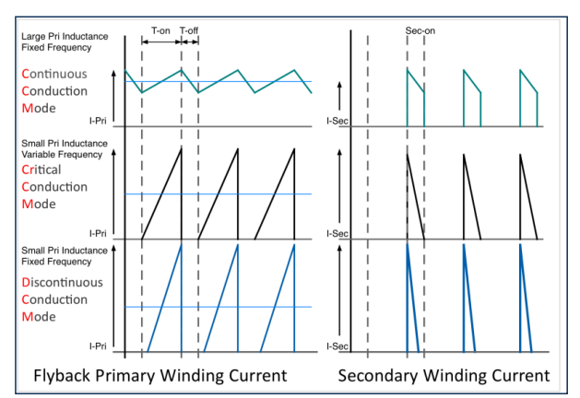There is also a critical conduction mode for the flyback which involves adjusting the on and off times of the primary switch just enough to get the inductor current to zero. The design of this mode is complex and is affected more by circuit parasitics.

Figure 3 CCM, DCM and critical conduction modes [4]

The above modes can be achieved either by choosing smaller inductances as shown in Figure 3 and/or using smaller on-periods for the MOSFET.

DCM is used for lighter loads and low power as it results in a smaller transformer and zero reverse recovery loss on rectifier diode and low turn-on loss for flyback switch. Hence in this thesis a flyback is designed to operate in the discontinuous mode. [5]

**2.2.2 Pulse Width Modulation (PWM) vs. Pulse Frequency Modulation (PFM)**

PWM is not the only technique for regulating the output of a switching converter. Instead of modifying the duty cycle of a fixed-frequency square wave to regulate the output of a power supply, it is also possible to use a constant duty cycle and then modulate the square wave’s frequency (PFM) to achieve regulation. DC/DC voltage converters equipped with constant-on-time or constant-off-time control are typical examples of PFM architecture.

PFM architectures offer some advantages for DC/DC conversion, including better low-power conversion efficiency, lower total solution cost, and simple converter topologies that do not require control-loop-compensation networks, but are less popular than PWM devices due to difficulty in controlling the EMI. [6]

It is easier to design a filter circuit for a fixed frequency switching converter than those that have a wide range of operating frequencies. But, this problem is mitigated because the root cause of such interference is fast switching at high currents and voltages. Since this is a low power converter, the current and switching frequency are low and hence PFM is chosen in this converter.

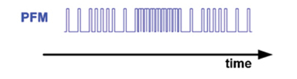

Figure 4 Pulse Frequency Modulation [7]

**3 Ideal Flyback Converter**

As seen in Figure 5, the flyback is used to charge a battery and is an ideal representation (free of parasitic elements).



Figure 5 Ideal Flyback converter with a fixed output (battery)

As explained in the previous sections, the flyback converter is operated in discontinuous conduction mode and a pulse frequency modulation is used to control the switch.

Thus there are three operational stages for this flyback converter.

**3.1 Stage 1: The switch on the primary side is “on”.**

In the first stage, the MOSFET is conducting and the diode does not conduct. It is important to note that this occurs due to the polarity of the secondary side being opposite to the first and it causes the diode to be reverse biased. Thus the secondary side current is zero and the coupled inductance stores energy magnetically. This is seen as a rise in primary current until the primary switch is turned “off”. The primary current (*ip*) rise is a function of the input voltage *Vin* and the magnetizing inductance (primary inductance) *Lp*.

It is given by the formula,



Secondary side voltage is given by the formula,

*Vout = Vin * n*

where *n = N2/N1* (*N2* is the number of secondary turns and *N1* is the number of primary turns).

The flyback converter in stage 1 is as shown in Figure 6.



Figure 6 Flyback Converter Stage 1

**3.2 Stage 2: The switch on the primary side is “off” and the secondary switch (diode) is “on”.**

In the second stage, the MOSFET is open and the diode conducts. The primary side current is zero and the magnetically stored energy is dissipated as secondary current. The secondary current (*is*) decay is a function of the output voltage “*Vout*” and the secondary inductance “*Ls*”. The value of Ls is obtained by *Ls = Lp * n2* .

As it is current decay, it is given by the formula,



Primary side voltage is given by the formula,



where *Vf* is known as the “flyback” or reflected voltage.



Figure 7 Flyback Converter Stage 2

**3.3 Stage 3: Both switches are “off” and the current in the transformer is zero.**

In the third stage, both the MOSFET and the diode do not conduct. The primary side current is zero, as well as the secondary current.

**3.4 Waveforms**

Figure 7 represents the various currents and voltages mentioned above. As seen, the primary current reaches *Ip* (peak current) at the end of Stage 1. This current is dissipated through the secondary. But the peak of this secondary current is *Ip* * (*N1/N2*) (which is obtained by equating the ampere turns of the mutual inductor). This secondary current decays at a rate of (Vout / Ls).

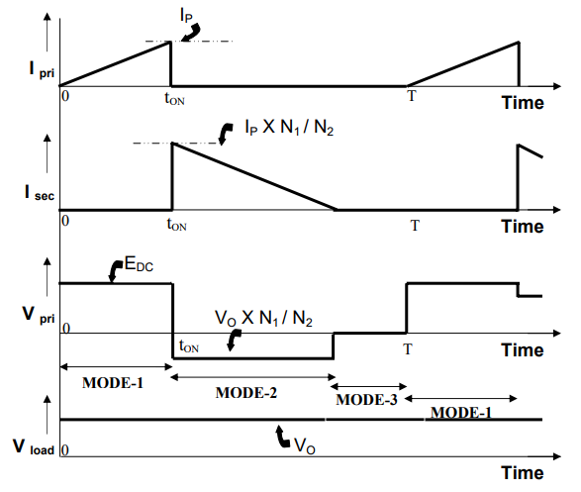

Stage 1

Stage 2

Stage 3

Figure 8 Waveforms of ideal flyback converter [8]

These equations were used to simulate the ideal flyback in MATLAB and cross checked with LTSpice. The converter was simulated in MATLAB in order to obtain efficiency curves with respect to various parameter sweeps. This will be discussed in the subsequent chapters.



Figure LTSpice Circuit of ideal flyback converter



Figure LTSpice waveforms

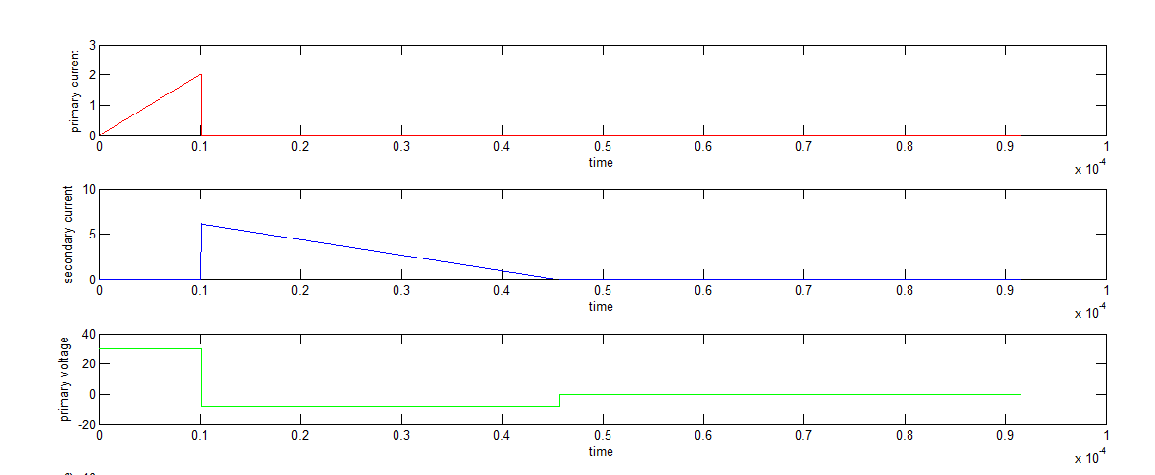

Figure Waveforms from MATLAB code

Thus the ideal flyback converter was satisfactorily simulated in MATLAB for currents and voltages. The next section deals with parasitic elements in the circuit which have a profound influence on losses and also the swings cause a higher voltage stress on the semiconductor elements than theoretically expected.

Bibliography:

1. <http://www.silego.com/products/greenpak.html>
2. <http://www.we-online.de/web/en/passive_components_custom_magnetics/blog_pbcm/blog_detail_electronics_in_action_45887.php>
3. N. Mohan, T. Undeland, and W. Robbins, *Power Electronics: Converters*, Applications, and Design, 3rd ed., New York: John Wiley & Sons, 2003.
4. <http://www.mouser.com/pdfdocs/2-8.pdf>
5. <http://www.mouser.com/pdfdocs/2-8.pdf>
6. <https://www.digikey.com/en/articles/techzone/2014/mar/the-advantages-of-pulse-frequency-modulation-for-dc-dc-switching-voltage-converters>
7. <https://www.digikey.com/en/articles/techzone/2014/mar/the-advantages-of-pulse-frequency-modulation-for-dc-dc-switching-voltage-converters>
8. <http://www.nptel.ac.in/courses/Webcourse-contents/IIT%20Kharagpur/Power%20Electronics/PDF/L-22(DP)(PE)%20((EE)NPTEL).pdf>